**Awesome Miner Configuration setup with Bleumintcoin guide:**

**Step 1:** Go to https://www.awesomeminer.com and download the Awesome miner Windows application. (Any other free mining tool, such as CGMiner, EasyMiner, etc., can be used.)

**Step 2:** Install the tool on your local machine when it has been downloaded.

**Step 3:** Include/Add a new pool and modify its settings as seen in the image below.

* Pool connection URL: **url=stratum+tcp://5.161.79.86:3433** (Note that this is Our **Hub 1**)
* Pool connection URL: **url=stratum+tcp:// 167.235.74.69:3433** (Note that this is Our **Hub 2**)
* Pool connection URL: **url=stratum+tcp:// 168.119.175.203:3433** (Note that this is Our **Hub 3**)
* Worker name: Your Wallet Id
* Worker password: c=BLEU (This is optional)
* Coin: Scrypt

Note: Pool connection: You can connect to any one of our three hubs to start mining using the information above.

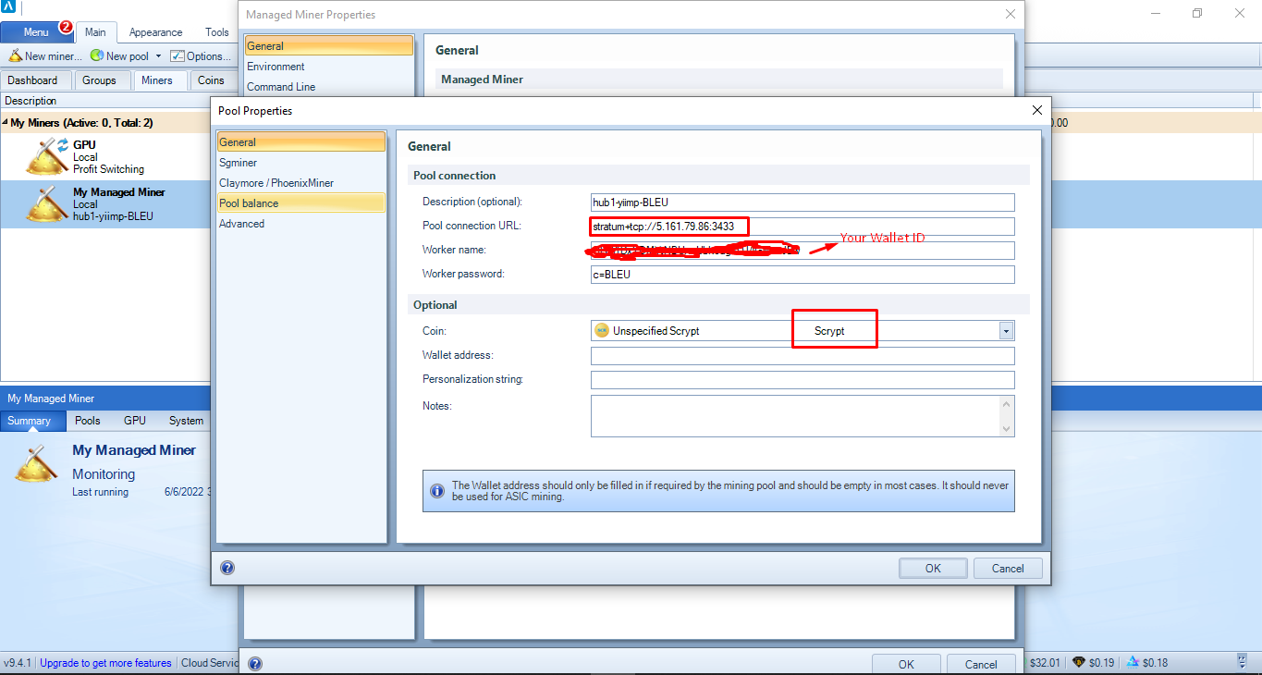

**Step 4:** When the aforementioned steps have been finished, add "New miner" to the top of the tab in the awesome miner tool.

**Step 5:** Add the characteristics shown in the images below.

Algorithm: Scrypt

Managed Host: Local

Mining Program: CpuMiner-Opt (Change as per your system config)

Pool: Enter the name of the pool you created in Step 3 and click "OK"

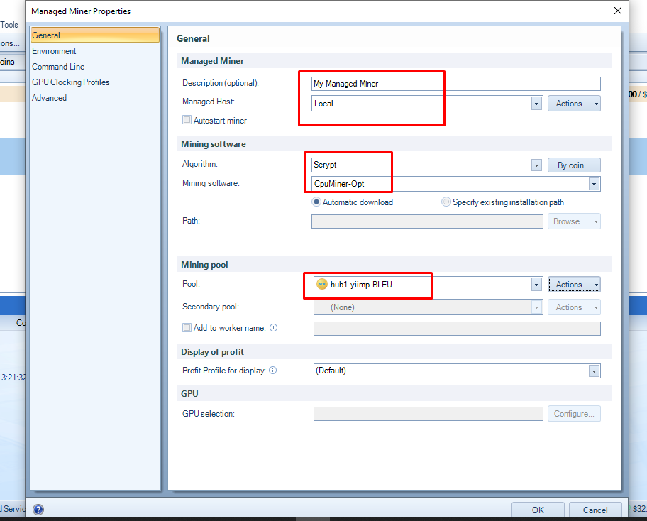

Once all of the aforementioned steps have been completed, you may view the list of miners and your own status in the dashboard. By using the "Right Click" option, you may view the mining details. Please see the picture below.

